Bangladesh University of Engineering and Technology
Department of Electrical and Electronic Engineering

EEE xxx (January 2022)
Full Title of the Course Laboratory
Final Project Report
Section: A1 Group: 01

Title of the Project Goes Here

Course Instructors:
Full Name 1, Assistant Professor
Full Name 2, Part-Time Lecturer

Signature of Instructor: ___________________________________________________

Academic Honesty Statement:
IMPORTANT! Please carefully read and sign the Academic Honesty Statement, below. Type the student ID and name, and put your signature. You will not receive credit for this project experiment unless this statement is signed in the presence of your lab instructor.
“In signing this statement, We hereby certify that the work on this project is our own and that we have not copied the work of any other students (past or present), and cited all relevant sources while completing this project. We understand that if we fail to honor this agreement, We will each receive a score of ZERO for this project and be subject to failure of this course.”
Signature: ____________________________  Full Name:  Student ID: 1806xyz | Signature: ____________________________  Full Name:  Student ID:
Signature: ____________________________  Full Name:  Student ID: | Signature: ____________________________  Full Name:  Student ID:

Table of Contents
1 Abstract 1
2 Introduction 1
3 Design 1
3.1 Problem Formulation (PO(b)) 1
3.1.1 Identification of Scope 1
3.1.2 Literature Review 1
3.1.3 Formulation of Problem 1
3.1.4 Analysis 1
3.2 Design Method (PO(a)) 1
3.3 Circuit Diagram 1
3.4 Simulation Model 2
3.5 CAD/Hardware Design 2
3.6 PCB Design 2
3.7 Full Source Code of Firmware 2
3.8 2
4 Implementation 2
4.1 Description 2
5 Design Analysis and Evaluation 3
5.1 Novelty 3
5.2 Design Considerations (PO(c)) 3
5.2.1 Considerations to public health and safety 3
5.2.2 Considerations to environment 3
5.2.3 Considerations to cultural and societal needs 3
5.3 Investigations (PO(d)) 3
5.3.1 Design of Experiment 3
5.3.2 Data Collection 3
5.3.3 Results and Analysis 3
5.3.4 Interpretation and Conclusions on Data 3
5.4 Limitations of Tools (PO(e)) 3
5.5 Impact Assessment (PO(f)) 3
5.5.1 Assessment of Societal and Cultural Issues 4
5.5.2 Assessment of Health and Safety Issues 4
5.5.3 Assessment of Legal Issues 4
5.6 Sustainability Evaluation (PO(g)) 4
5.7 Ethical Issues (PO(h)) 4
6 Reflection on Individual and Team work (PO(i)) 4
6.1 Individual Contribution of Each Member 4
6.2 Mode of TeamWork 4
6.3 Diversity Statement of Team 4
6.4 Log Book of Project Implementation 4
7 Communication to External Stakeholders (PO(j)) 5
7.1 Executive Summary 5
7.2 User Manual 5
7.3 Github Link 5
7.4 YouTube Link 5
8 Project Management and Cost Analysis (PO(k)) 5
8.1 Bill of Materials 5
8.2 Calculation of Per Unit Cost of Prototype 5
8.3 Calculation of Per Unit Cost of Mass-Produced Unit 5
8.4 Timeline of Project Implementation 5
9 Future Work (PO(l)) 5
10 References 5

Abstract
Write your abstract here

This section is mandatory to write. In your final report, remove all blue texts. Use the normal style. Remove all yellow highlighting, and write correct texts.

Introduction
Write here using the normal text style from the tool bar.….
This section is mandatory to write. Introduce the problem. Describe how your problem is a Complex Engineering Problem, and describe possible alternative solutions.

Design

Problem Formulation (PO(b))
This section is mandatory to write if the course outcomes address PO(b). Read the PO Statement in the website first, before writing this section (Program Outcomes and Program Educational Objectives | Department of EEE, BUET) If not needed, remove this entire section. If needed, DO NOT Change the title of this section.

Identification of Scope

Literature Review

Formulation of Problem

Analysis

Design Method (PO(a))
This section is mandatory to write if the course outcomes address PO(a).Write in details, how you applied knowledge of mathematics, science, and engineering to solve the problem. Give necessary mathematical derivations, equations etc. If not needed, remove this entire section. If needed, DO NOT Change the title of this section.

Circuit Diagram
If appropriate for your project. Otherwise, remove this section

Simulation Model
If appropriate for your project. Otherwise, remove this section

CAD/Hardware Design
If appropriate for your project. Otherwise, remove this section

PCB Design
If appropriate for your project. Otherwise, remove this section

Full Source Code of Firmware
If appropriate for your project. Otherwise, remove this section

Use small font size, Consolas Size 7, double column
Test

Table: Source Code for the main program

Implementation

Description
This is the description for the design
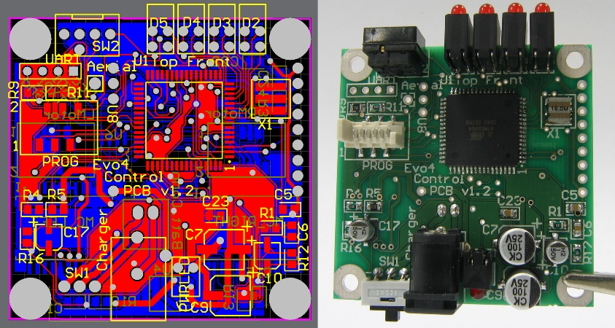
Figure 2: (Left) PCB Layout and (Right) Implementation of Design

Design Analysis and Evaluation

Novelty

Design Considerations (PO(c))
This section is mandatory to write if the course outcomes address PO(c) Read the PO Statement in the website first, before writing this section (Program Outcomes and Program Educational Objectives | Department of EEE, BUET) If not needed, remove this entire section. If needed, DO NOT Change the title of this section.

Considerations to public health and safety

Considerations to environment

Considerations to cultural and societal needs

Investigations (PO(d))
This section is mandatory to write if the course outcomes address PO(d) Read the PO Statement in the website first, before writing this section (Program Outcomes and Program Educational Objectives | Department of EEE, BUET) . If not needed, remove this entire section. If needed, DO NOT Change the title of this section.

Design of Experiment

Data Collection

Results and Analysis

Interpretation and Conclusions on Data

Limitations of Tools (PO(e))
This section is mandatory to write if the course outcomes address PO(e) Read the PO Statement in the website first, before writing this section (Program Outcomes and Program Educational Objectives | Department of EEE, BUET). If not needed, remove this entire section. If needed, DO NOT Change the title of this section. You need to write the technological limitations of your tools used, maximum limit, tolerances, probable errors

Impact Assessment (PO(f))
This section is mandatory to write if the course outcomes address PO(f) Read the PO Statement in the website first, before writing this section (Program Outcomes and Program Educational Objectives | Department of EEE, BUET). If not needed, remove this entire section. If needed, DO NOT Change the title of this section.

Assessment of Societal and Cultural Issues

Assessment of Health and Safety Issues

Assessment of Legal Issues

Sustainability Evaluation (PO(g))
This section is mandatory to write if the course outcomes address PO(g) Read the PO Statement in the website first, before writing this section (Program Outcomes and Program Educational Objectives | Department of EEE, BUET). If not needed, remove this entire section. If needed, DO NOT Change the title of this section.

Ethical Issues (PO(h))
This section is mandatory to write if the course outcomes address PO(h) Read the PO Statement in the website first, before writing this section (Program Outcomes and Program Educational Objectives | Department of EEE, BUET). If not needed, remove this entire section. If needed, DO NOT Change the title of this section.

Write in details, how you applied ethical principles to solve this project. Write any issues where you faced ethical challenges and how you mitigated them.

Reflection on Individual and Team work (PO(i))
This section is mandatory to write if the course outcomes address PO(h) Read the PO Statement in the website first, before writing this section (Program Outcomes and Program Educational Objectives | Department of EEE, BUET). If not needed, remove this entire section. If needed, DO NOT Change the title of this section.

Individual Contribution of Each Member

Mode of TeamWork

Diversity Statement of Team

Log Book of Project Implementation
Date | Milestone achieved | Individual Role | Team Role | Comments

Communication to External Stakeholders (PO(j))
This section is mandatory to write if the course outcomes address PO(j) Read the PO Statement in the website first, before writing this section (Program Outcomes and Program Educational Objectives | Department of EEE, BUET). . If not needed, remove this entire section. If needed, DO NOT Change the title of this section. Also, communication marks would consist writing this report properly with correct formatting.

Executive Summary
Write a 100 word press release for your project that would be easy to understand by the masses.

User Manual

Github Link

YouTube Link
Write a detailed step by step user guide for your project.

Project Management and Cost Analysis (PO(k))
This section is mandatory to write if the course outcomes address PO(k) Read the PO Statement in the website first, before writing this section (Program Outcomes and Program Educational Objectives | Department of EEE, BUET) . If not needed, remove this entire section. If needed, DO NOT Change the title of this section.

Bill of Materials

Calculation of Per Unit Cost of Prototype

Calculation of Per Unit Cost of Mass-Produced Unit

Timeline of Project Implementation
Add a Gantt chart here

Future Work (PO(l))
This section is mandatory to write if the course outcomes address PO(l) Read the PO Statement in the website first, before writing this section (Program Outcomes and Program Educational Objectives | Department of EEE, BUET)

References

