Put the Title of Your Thesis Here

by

Candidate Name 042106XYZA

MASTER OF SCIENCE IN
ELECTRICAL AND ELECTRONIC ENGINEERING

.

Department of Electrical and Electronic Engineering Bangladesh University of Engineering and Technology
Dhaka, Bangladesh

September 2020

The thesis titled, “Put the Title of Your Thesis Here”, submitted by Candidate Name, Roll No.: 042106XYZA, Session April 2021, has been accepted as satisfactory in par- tial fulfillment of the requirements for the degree of Master of Science in Electrical and Electronic Engineering on 15 September 2020.

BOARD OF EXAMINERS

Dr. Fname Lname Chairman
Assistant Professor (Supervisor)
Dept. of EEE, BUET, Dhaka

Dr. Head Name Member
Professor and Head (Ex-Officio)
Dept. of EEE, BUET, Dhaka

Dr. Member Name Member
Professor
Dept. of EEE, BUET, Dhaka

Dr. Member Name Member
Professor
Dept. of EEE, BUET, Dhaka

Dr. External Name Member
Professor (External)
Dept. of XXX, Affiliation, City

Candidate’s Declaration

This is to certify that the work presented in this thesis entitled, “Put the Title of Your Thesis Here”, is the outcome of the research carried out by Candidate Nameunder the supervision of Dr. First Last, Assistant Professor, Department of Electrical and Elec- tronic Engineering, Bangladesh University of Engineering and Technology (BUET), Dhaka-1205, Bangladesh.

It is also declared that neither this thesis nor any part thereof has been submitted any- where else for the award of any degree, diploma, or other qualifications.

Signature of the Candidate

Candidate Name 042106XYZA

Dedication

Write dedication in pages/dedication.tex
You may delete this segment:
The LATEX- Thesis template is maintained by Dr. Sajid Muhaimin Choudhury. There might be some errors in the template, so always listen to your own committee members’ advice while finalizing the thesis. Please let me know if there are any needed corrections to this template. sajid@eee.buet.ac.bd

CONTENTS
Contents
Candidate’s Declaration 3
Dedication 4
List of Figures 6
List of Tables 7
ACKNOWLEDGEMENT 8
ABSTRACT 9
1. INTRODUCTION 10
1.1 Problem Statement 10
1.2 Objectives of the Thesis 10
1.3 Thesis Outline 10
1.4 How to use this template. 10
2. LITERATURE REVIEW 13
3. BACKGROUND 14
4. PROPOSED SYSTEM 15
5. EXPERIMENTAL RESULTS 16
6. CONCLUSIONS 17
6.1 Conclusions 17
6.2 Future Prospects of Our Work 17
REFERENCES 18

List of Figures

Figure 1-1 Figure No 1 11
Figure 1-2 Figure No 2 11
Figure 2-1 Figure No 2 13

List of Tables

Table 4-1 Example Table 15

  - Example Table 5

ACKNOWLEDGEMENT

Write the text for acknowledgement in pages/acknowledgement.tex

ABSTRACT

Write Abstract in pages/abstract.tex

INTRODUCTION

Here is a Small Tutorial Section on the template

Problem Statement

Section text. Figure 1.1.

Objectives of the Thesis

From the proposal

Thesis Outline

The rest of this thesis is organized as follows.

How to use this template.

Using Microsoft Word’s built-in styles makes your document consistent, professional, and easy to update. It also ensures your Table of Contents, figure numbering, and cross-references work automatically. The tutorial is generated with ChatGPT 5 model.

1. Apply Styles Instead of Manual Formatting
- Do NOT bold, change font size, or add spacing manually for headings.
- Instead, place your cursor on the heading text (e.g., Chapter 1: Introduction) and select a style from the Styles Pane (usually on the “Home” tab).
👉 Use:
- Heading 2 → For chapter titles (e.g., 2. Introduction, Methodology)
- Heading 3 → For sections (e.g., 2.1 Background)
- Heading 4 → For subsections (e.g., 2.1.1 Motivation)
Why?
- Styles control font, size, and spacing automatically.
- You can change the look of all headings at once by modifying the style.
- Word can generate a Table of Contents directly from heading levels.
2. Copy Text with Styles (Not Formatting)
If you need to copy a heading into another document/template:
- Copy normally (Ctrl+C) and paste with Keep Text Only (Ctrl+Alt+V → Keep Text Only).
- Then reapply the correct style (Heading 1, Heading 2, etc.) in the new document.
⚠️ Do not copy and paste with formatting, otherwise you’ll drag mismatched fonts and spacing into the template.

For going to new page, give Insert>Page Break, or press Ctrl+Enter instead of linebreaks

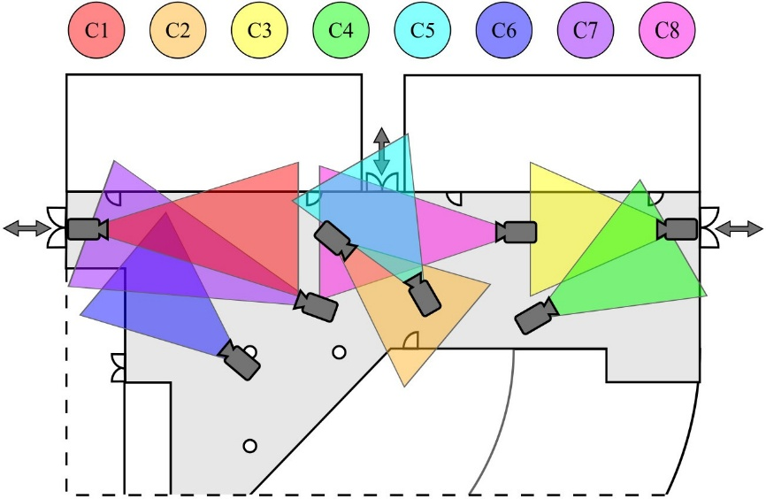
Figure 1-1 Figure No 1

Figure 1-2 Figure No 2
3. Insert Figures and Captions Properly
- Insert a figure (e.g., picture, graph).
- Right-click → Insert Caption.
- Choose Label: Figure.
- Word will generate: Figure 1.1. Caption text.
Benefits

Figures are numbered automatically.
If you add or move figures, numbers update (References → Update Captions).
You can insert a List of Figures just like a Table of Contents.

4. Cross-Referencing Figures and Headings
- To refer to a figure in text, go to References → Cross-reference.
- Choose Figure (or Heading) and insert the reference.
- If numbers change later, cross-references update automatically (press Ctrl+A → F9).

Example Figure 1-1 shows a sample image.

5. Generate Table of Contents / Lists
- Go to References → Table of Contents → choose a style.
- Word will automatically use all Heading 1–3 text.
- Similarly, you can generate a List of Figures and List of Tables.

For reference and citation management, use Mendeley / Zotero. Use the BUETcsl style to match with the CASR approved requirement.

https://eee.buet.ac.bd/academic/postgraduate/thesis

LITERATURE REVIEW

Filename: chapters/literature review.tex Literature review chapter. Citation example [1].
Add the references in buet msc thesis.bib files in bibtex format.

Figure 2-1 Figure No 2

BACKGROUND

Filename: chapters/background.tex Background chapter. Add sections as necessary.

PROPOSED SYSTEM

Filename: chapters/methodology.tex
In this chapter, we discuss the proposed system...

Table 4-1 Example Table

Hyperparameter Value

Optimizer Adam [2]
Objective function Fusion of softmax and center loss
Epochs 450
Initial learning rate 5 × 10⁻³
Mini-batch size 256

EXPERIMENTAL RESULTS

Filename: chapters/result discussion.tex
In this chapter, we are going to evaluate our proposed method ...

CONCLUSIONS

Filename: chapters/conclusion.tex

Conclusions

Future Prospects of Our Work

REFERENCES

- Rida, I., Almaadeed, N. and Almaadeed, S. “Robust gait recognition: a compre- hensive survey.” IET Biometrics, volume 8, no. 1:pp. 14 – 28, January 2019
- Kingma, D.P. and Ba, J. “Adam: A method for stochastic optimization.” In “3rd Int. Conf. on Learning Representations,” San, Diego, 2015

