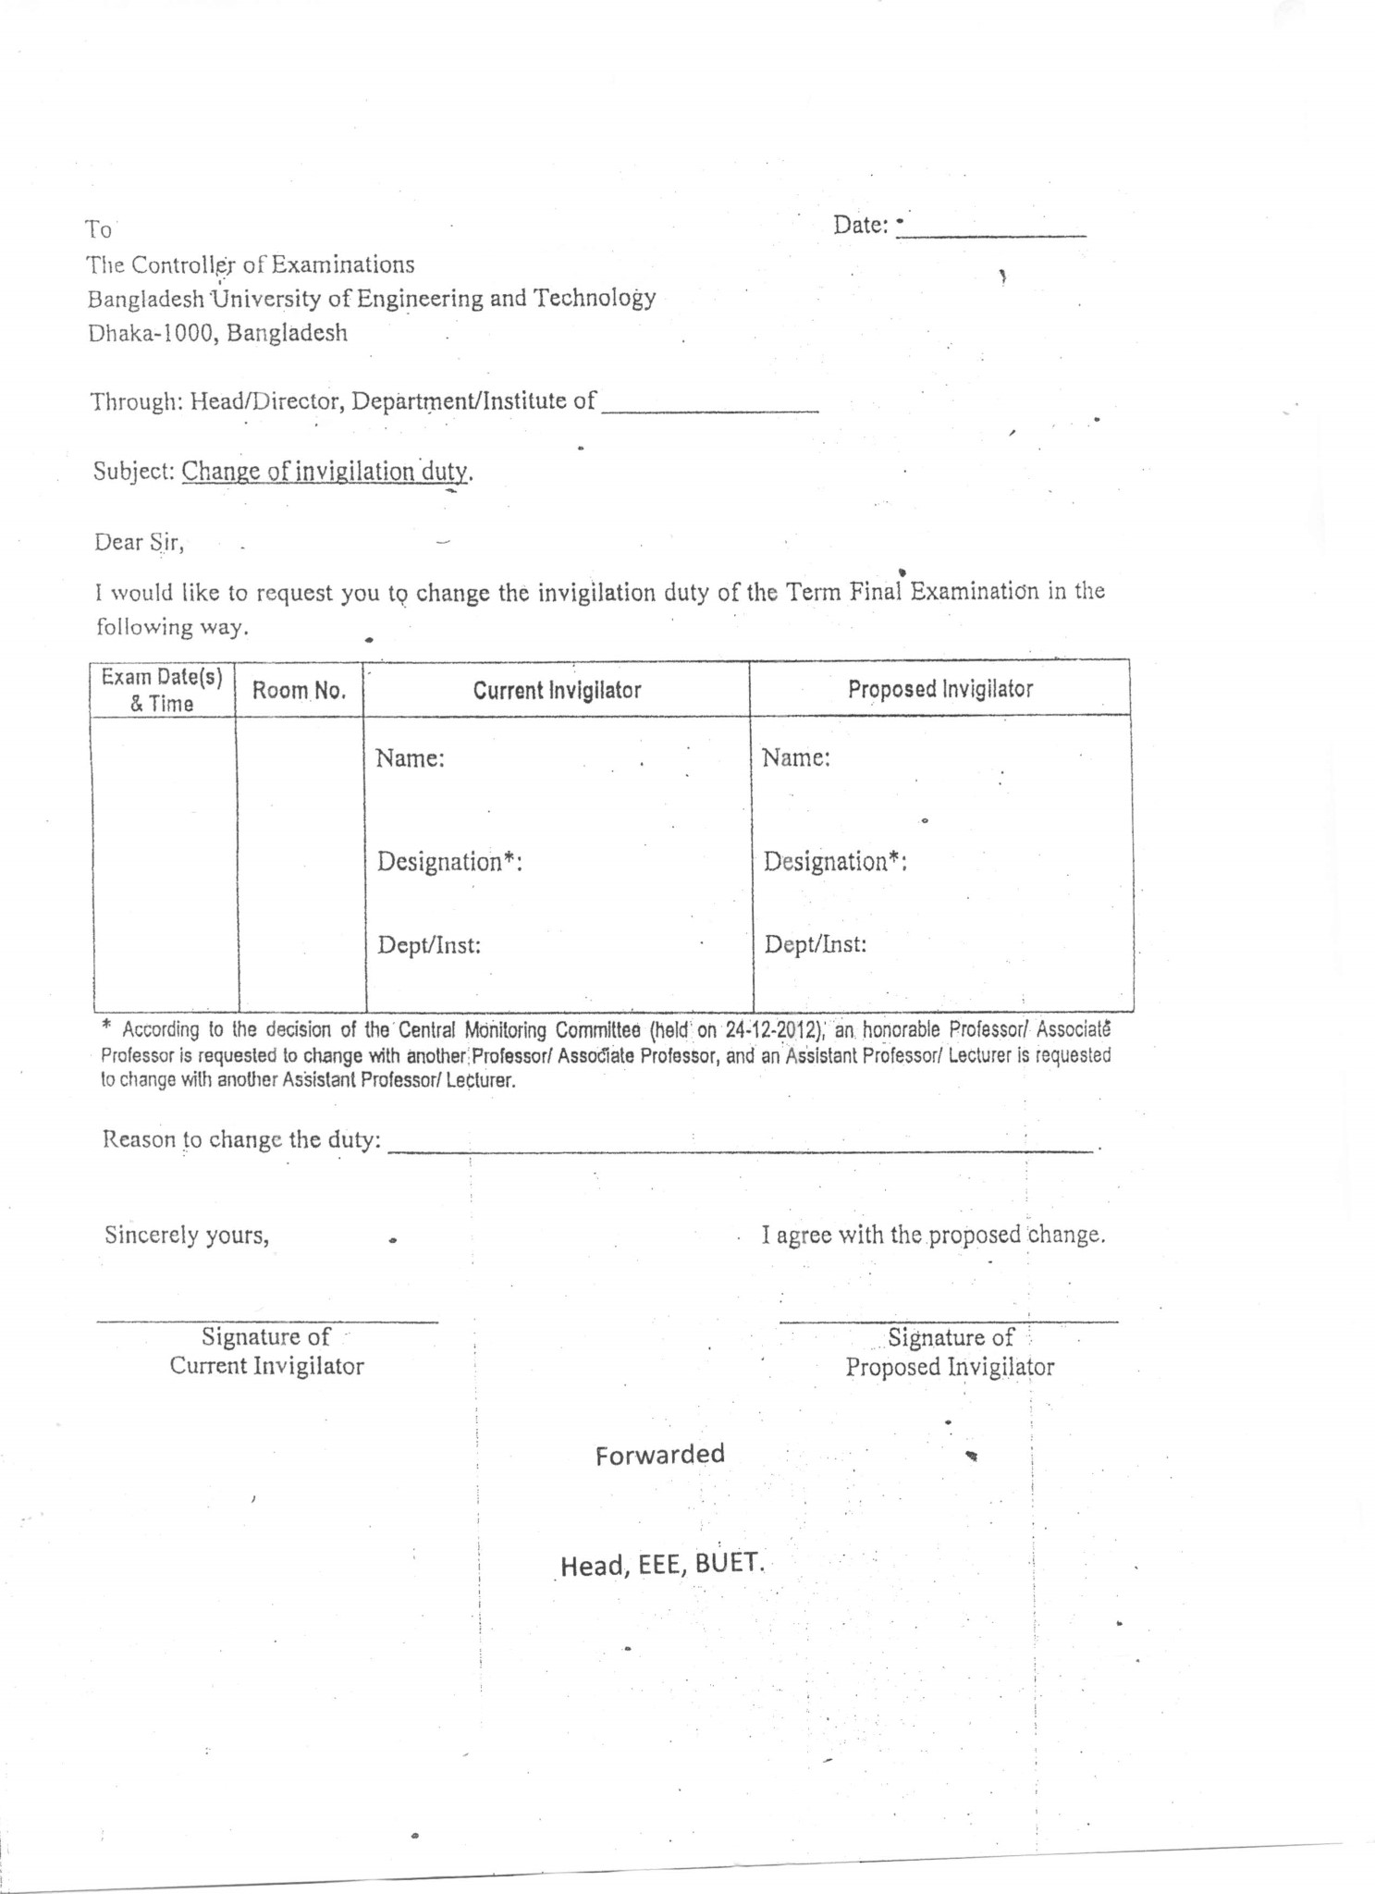

**dd.mm.yyyy**

**9am-12pm**

**Write your reason**

**EEE**

**EEE**

**Lecturer**

**Assistant Professor**

**Mr. XYZ**

**Dr. xyz**

**CE xxx**

**---------**

**EEE**

**DD.MM.YYYY**